2022 U.S. Partnership Grant Program – Request for Proposals

Overview
Pacific Birds Habitat Joint Venture (Pacific Birds) is requesting proposals from U.S. partners for its 2022 Partnership Grant Program.
Migratory Bird Joint Ventures are cooperative, regional partnerships located in the United States, Canada and Mexico. Pacific Birds is a habitat-based Migratory Bird Joint Venture with a mission of creating the ideal environment for bird habitat conservation.
Joint Ventures accomplish their work when partners work towards common conservation goals. Since 1987, Migratory Bird Joint Ventures have protected a network of 24 million acres of key habitat – thanks to partners working together.
Pacific Birds helps partners identify, prioritize, and implement conservation actions that benefit birds and the habitats they need. These actions include but are not limited to conserving habitat, inspiring action for bird conservation, developing and synthesizing data, increasing organizational capacity, and creating and sustaining partnerships that enact local or regional habitat conservation work.
Learn more about Pacific Birds Habitat Joint Venture.
Learn more about Pacific Birds conservation priorities.
Learn more about previously awarded projects.
Learn more about Migratory Bird Joint Ventures.
Grant Focus
Proposals for projects that support the Pacific Birds mission and address the conservation priorities and actions listed below will be considered for funding.
Conservation Priorities
Hawai‘i Wetlands
In Hawai‘i, proposed projects/programs should sustainably benefit wetland habitat, threatened or endangered Hawaiian birds, or migratory bird species that rely on wetlands.
In particular, we welcome proposals that:
1. Support wetland partnership initiatives that build local capacity. Examples include but are not limited to convening experts to answer particular questions on wetland restoration and management, the development of landscape level plans for wetland restoration, or bringing together local groups to carry out particular wetland conservation actions.
2. Facilitate the restoration or protection of additional wetland habitat acreage for birds. In particular, projects that incorporate the co-benefits of wetland habitat to mitigate for climate change impacts.
3. Research or implementation projects that further our understanding of the values and management practices of loʻi kalo (taro fields) as they relate to bird conservation.
4. Improve our understanding of the habitat requirements of threatened and endangered waterbirds in Hawaiʻi.
5. Address predator control needs, which may include outreach and communication efforts beneficial to wetland birds.
Oak and Prairie
For Oak and Prairie, proposed projects/programs should sustainably benefit this habitat and native birds. If a partner-driven oak and/or prairie strategic plan is available for your geography, projects should reflect priorities identified in that plan.
In particular, we welcome proposals that:
- Increase the effectiveness and capacity of local and collaborative oak and prairie partnerships including, but not limited to, coordination, outreach to new partners, and strategic planning.
- Advance strategies that regionally benefit oak and prairie habitats including but not limited to advancing landowner incentive programs, building prescribed fire capacity, conservation workforce development, increasing landowner access to technical assistance, and increasing awareness of the value of oak and prairie habitats and related threats to target audiences.
- Further research projects related to Human Dimensions including but not limited to how people’s knowledge, values, and behaviors influence and are affected by oak and prairie conservation actions.
Coastal Wetlands
For Coastal Wetlands, proposed projects/ programs should sustainably benefit coastal wetlands and native birds. Coastal wetlands include habitats within and surrounding estuaries and freshwater wetlands that extend inland within the coastal drainages.
In particular, we welcome proposals that:
- Increase the capacity of collaborative partnerships including partnership development, coordination, outreach to new partners, and strategic planning.
- Assist projects and/or programs that support efforts for coastal wetland conservation and birds.
- Further communications, research, and prioritization related to the conservation of coastal wetland habitat and native birds, especially related to climate change and expected future conditions. Projects should benefit management decision making for habitat and bird conservation.
- Advance the strategies identified in the Pacific Americas Shorebird Conservation Strategy and/ or the North American Waterfowl Management Plan.
Program Specifics
Grant and Match Funds: Grant applications will be accepted up to a maximum of $20,000 but most awards will be in the range of $5,000 to $15,000.
Match funding is not required, but projects that include match will receive additional consideration. Funds from Pacific Birds may not be used to support political advocacy, fundraising, lobbying, litigation, terrorist activities, or Foreign Corrupt Practices Act violations. Funds will be restricted to the items outlined in the grant application budget. If you are awarded a grant, any budgetary changes will need to be approved by Pacific Birds in advance of expenditure.
Eligibility: Proposals led by Indigenous peoples, organizations, and communities working to advance Indigenous priorities within the scope of this opportunity are particularly encouraged to apply.
This program provides grants to non-profit 501(c) organizations, state government agencies, local governments, municipal governments, Native American tribal governments, Native Hawaiian Organizations, and educational institutions. Tribal governments include all Native American tribal governments (both federally recognized tribes and those tribes that are not federally recognized). We are unable to make grants to for-profit corporations, federal agencies, or individuals.
Indirect costs are limited to ten percent of the total budget.
Contact Pacific Birds if the proposed project includes use of funds for implementation that require permits.
Time extensions for awarded funds will not be granted. Priority will be given to projects that can be completed by July 15, 2023. All other projects must be completed by July 15, 2024. Time extensions for awarded projects will not be allowed. Please do not apply if your proposal cannot be completed by one of the above dates.
Geography: Grants will only be awarded to projects within these regions of Pacific Birds: Alaska, Hawaiʻi, and the western portions of Washington, Oregon and northern California.

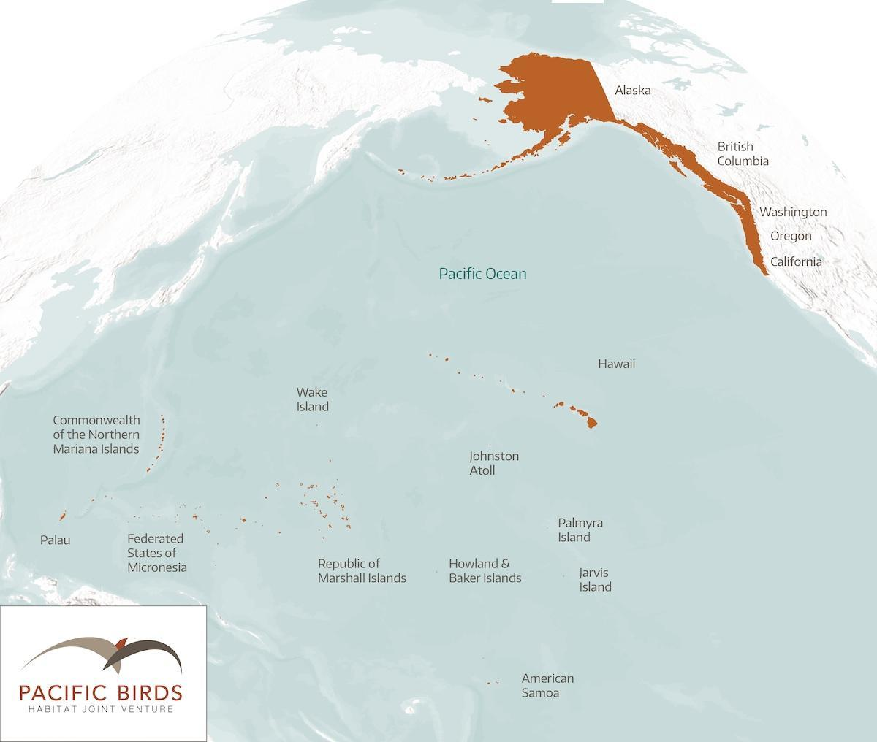
Application Deadline: no later than 11:59 PM PDT on Thursday June 30, 2022
How To Apply: Please submit a PDF document via email with the subject line: 2022 Pacific Birds Partnerships Grants to Monica Iglecia (U.S. Coordinator) at monica_iglecia@pacificbirds.org.
The PDF document should contain the below information.
Application Content:
- Organization Name:
- EIN
- Address
- City, State, Postal Code
- Project Contact Name
- Project Contact Title
- Phone
- Email
- Your organization's mission and how it relates to bird habitat conservation (max 200 words)
- Focus Area/Conservation Priority applying for (Hawai‘i Wetlands / Oak and Prairie / Coastal Wetlands)
- Description of Project. Include:
  - Project Name
  - Project Partners (if applicable)
  - Project Executive Summary (max 100 words)
  - Requested amount
  - Match available (match is not required)
  - Geographic Area of Focus (include map)
  - Project Goal(s) (max 200 words)
  - Key Project Actions(s) (max 200 words)
  - Expected Bird Beneficiaries Table - provide 5-10 species expected to benefit from this project and check the boxes if species are present on any of the following lists. Contact Pacific Birds staff if you need assistance.

Common Name / Scientific Name | 3 Billion Birds & Pacific Birds: Crossover Species  Include any species in highlighted green areas of table. | Hawaiʻi’s Threatened and Endangered Waterbirds | Imperiled Oak and Prairie Landbird Species | Shorebirds of Conservation Concern in the USA | NAWCA Priority Species  (Waterfowl and/or non-waterfowl by BCR)
add species name here

- Expected Project Benefits and how you will measure success (max 450 words).
- Expected Project Benefits Summary Table (note - projects do not need to provide benefits in all categories)

Task Description | Number | Comments
Total acres protected
Total acres restored
Total acres enhanced
Positions established
Conservation easements acquired
Conservation plans developed
Landowner visits
Partnering organizations involved
Meetings/work groups facilitated
Field tours hosted
Grant proposals written
Outreach documents produced
Technical documents produced–data and maps
Other

- Project Budget - itemized table

- If you receive less than the amount requested, will you be able to proceed with the project and if so, how will you scale it down?

- If you receive funds, indicate the earliest date by which you will be able to spend the funds and request reimbursement. If you are unable to spend funds by either of the below dates you do not qualify for this grant.
( ) July 15, 2023
( ) July 15, 2024
( ) Either deadline is feasible

- Project Timetable
- Permits and Compliance
  - If permits are required for this project, do you have them in hand?
  - If compliance is needed, does this project meet the U.S. Fish and Wildlife Financial Assistance Award Terms and Conditions?
Grant Application and Award Dates
- Application closing date: 11:59 PM Pacific Daylight Time on Wednesday, June 30, 2022.
- Award notification date: July 29, 2022.
- Award date: August 31, 2022.
Reporting Requirements
Depending on funds allocated, reimbursement requests and reporting (a short report showing how funds were spent, and the benefit obtained) will be due by July 15, 2023 or July 15, 2024.
A template for the report and a reimbursement request form will be provided to successful applicants. By accepting a grant you give permission to Pacific Birds to report on grant activities on our website and/or in newsletters.
Compliance
All federally funded projects will be required to meet the U.S. Fish and Wildlife Financial Assistance Award Terms and Conditions.
Proposals involving ground disturbance will either need to demonstrate compliance with the following FWS pre-award compliance requirements, or demonstrate that the requirements are not applicable. Federally-funded projects involving ground disturbance will require the following before the Grant Agreement can be executed:
(a) Documentation of compliance with 36 CFR, Part 800, which implements the National Historic Preservation Act (NHPA), for all project activities;
(b) FWS documentation demonstrating compliance with the National Environmental Policy Act (NEPA) and the Endangered Species Act for all project activities;
(c) Documentation from FWS Regional Office or field station demonstrating that contaminants will not preclude the incorporation of those lands acquired in the project into the National Wildlife Refuge System (applicable only if such lands will be acquired in the project).

Questions?
For questions, please contact:
Helen Raine (Hawai‘i Wetlands)
helen_raine@pacificbirds.org 808-294-6626
Sara Evans-Peters (Oak and Prairie)
sara_evans_peters@pacificbirds.org 503-957-3282
Monica Iglecia (Coastal Wetlands)
Monica_iglecia@pacificbirds.org

